Emre Can Şen- 21902516

Section-2

Lab-03

Analytical Part

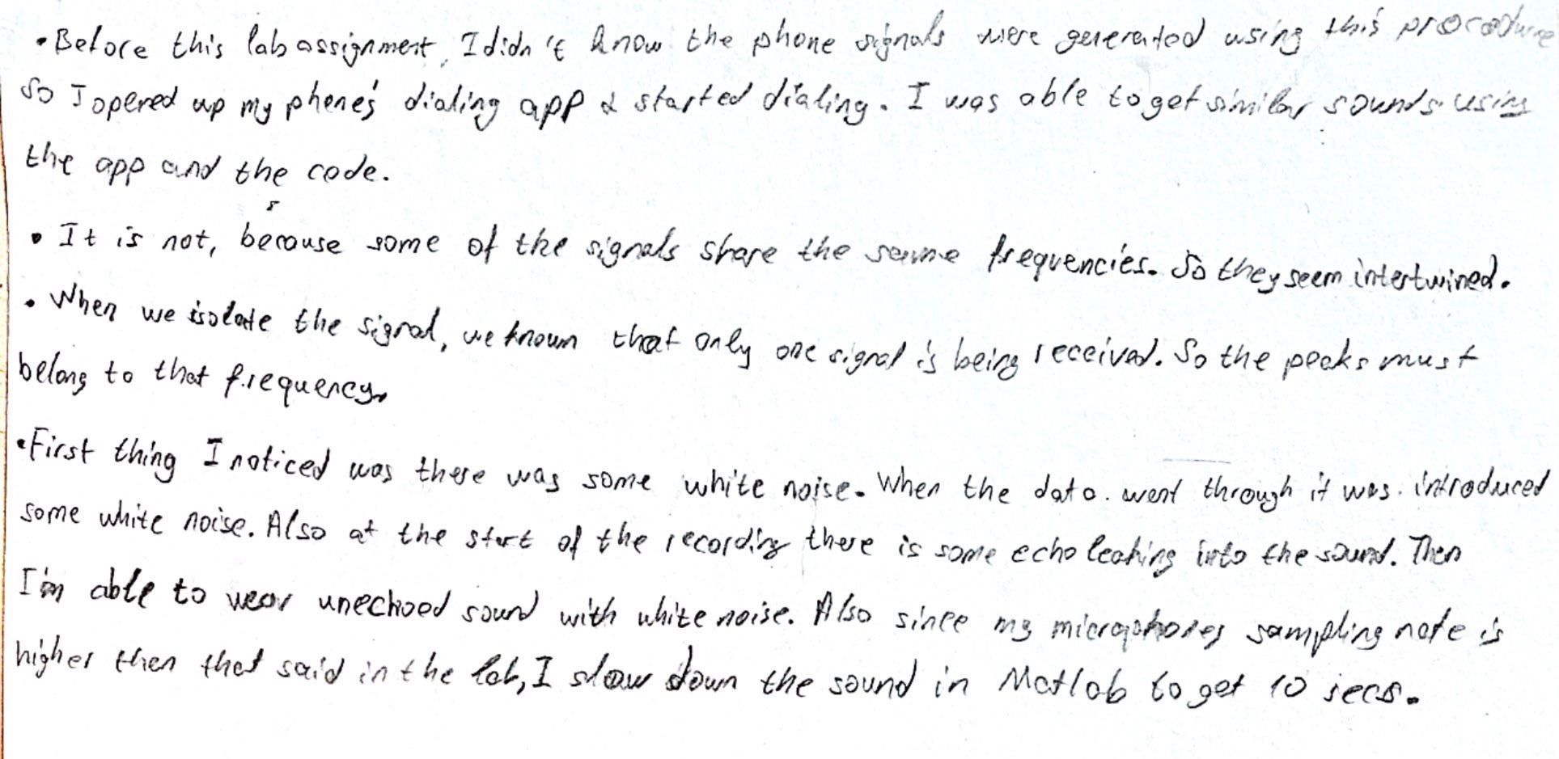

Figure 1- Written Answers

Analytical Part with Calculations

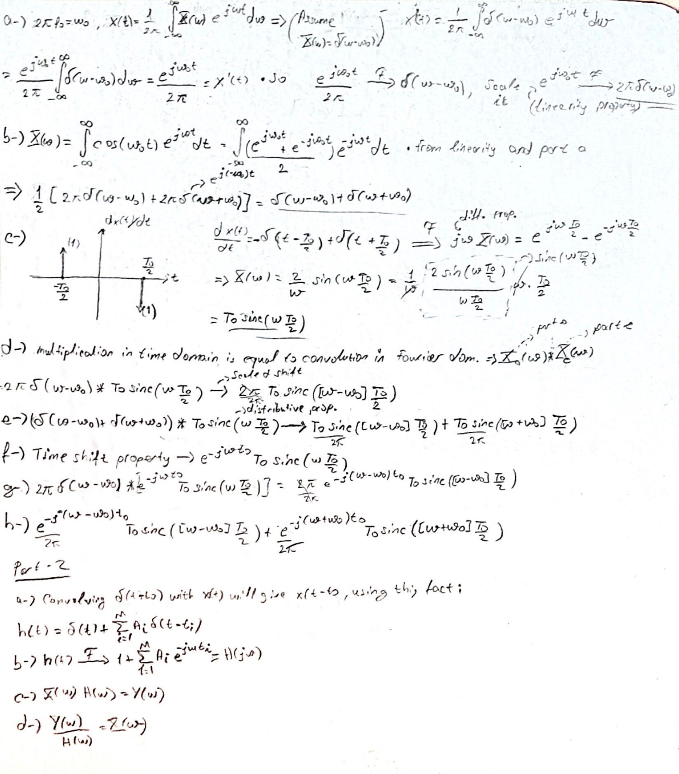

Figure 2- Calculated Answers

Plots

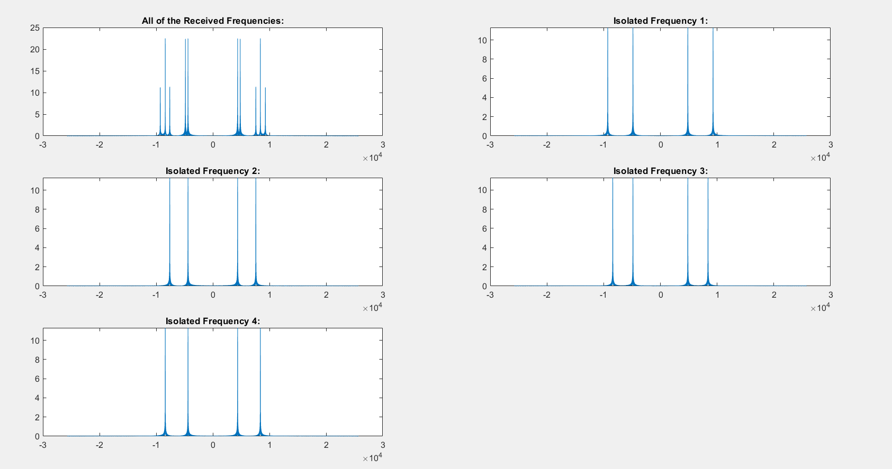

Figure 3- Frequency Plots

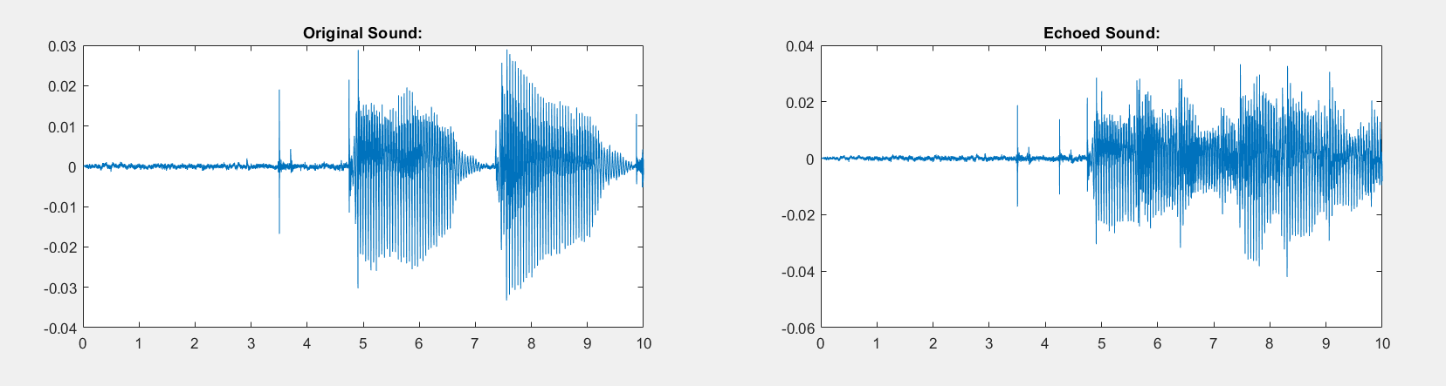

Figure 4- Sound Plots

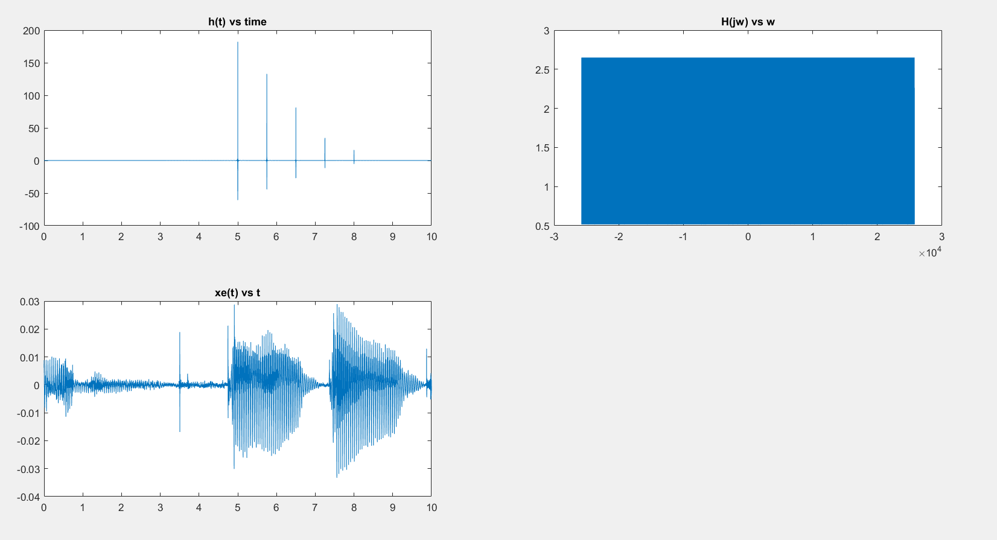

Figure 5- Transform Plots

MATLAB Code

Number=[6 1 5 2];

y=DTMFTRA(Number);

%soundsc(y);

figure(1)

X1=FT(y);

omega=linspace(-8192*pi,8192*pi,8193);

omega=omega(1:8193);

subplot(3,2,1)

plot(omega,abs(X1))

title('All of the Received Frequencies:')

kek1=ones(1,2049);

kek2=zeros(1,6144);

rect1=horzcat(kek1,kek2);

x1a=y.*rect1;

X1A=FT(x1a);

subplot(3,2,2)

plot(omega,abs(X1A))

title('Isolated Frequency 1:')

kek1=ones(1,2049);

kek3=zeros(1,2048);

rect2=horzcat(kek3,kek1,kek3,kek3);

x2a=y.*rect2;

X2A=FT(x2a);

subplot(3,2,3)

plot(omega,abs(X2A))

title('Isolated Frequency 2:')

rect3=horzcat(kek3,kek3,kek1,kek3);

x3a=y.*rect3;

X3A=FT(x3a);

subplot(3,2,4)

plot(omega,abs(X3A))

title('Isolated Frequency 3:')

rect4=horzcat(kek3,kek3,kek3,kek1);

x4a=y.*rect4;

X4A=FT(x4a);

subplot(3,2,5)

plot(omega,abs(X4A))

title('Isolated Frequency 4:')

%part2

sample=[1,(8192/4800)*Fs];

[y_sound,Fs] = audioread('alphabet.wav',sample);

y_sound_original=y_sound;

%soundsc(y_sound,Fs/6)

syms k

t=0:1/8192:10-1/8192;

M=4;

A_i=[0.75 0.5 0.25 0.15];

t_i=[0.75 1.5 2.25 3];

t_i=t_i.*8192;

z1=zeros(6144,1);

y1_sound=vertcat(z1,y_sound);

y1_sound=(0.75).*y1_sound(1:81920);

z2=zeros(12288,1);

y2_sound=vertcat(z2,y_sound);

y2_sound=(0.5).*y2_sound(1:81920);

z3=zeros(18432,1);

y3_sound=vertcat(z3,y_sound);

y3_sound=(0.25).*y3_sound(1:81920);

z4=zeros(24576,1);

y4_sound=vertcat(z4,y_sound);

y4_sound=(0.15).*y4_sound(1:81920);

y_sound=y_sound+y1_sound+y2_sound+y3_sound+y4_sound;

%soundsc(y_sound,Fs)

figure(2)

subplot(2,2,1)

plot(t,y_sound_original)

title('Original Sound:')

subplot(2,2,2)

plot(t,y_sound)

title('Echoed Sound:')

sound_fourier=FT(y_sound);

omega=linspace(-8192*pi,8192*pi,81921);

omega=omega(1:81920);

H_jw=1+0.75*exp(-1i*omega*0.75)+0.5*exp(-1i*omega*1.5)+0.25*exp(-1i*omega*2.25)+0.15*exp(-1i*omega*3);

h_time=IFT(H_jw);

figure(3)

subplot(2,2,1)

plot(t,h_time)

title('h(t) vs time')

subplot(2,2,2)

plot(omega,abs(H_jw))

title('H(jw) vs w')

H_jw=transpose(H_jw);

X_jw=rdivide(sound_fourier,H_jw);

x_e=IFT(X_jw);

soundsc(x_e,Fs/6)

subplot(2,2,3)

plot(t,x_e)

title('xe(t) vs t')

function x=DTMFTRA(Number)

N=(0.25).*[0:4/8192:length(Number)];

x=zeros(1,length(N));

for a= [1:length(Number)]

T=((a-1)*0.25<=N & N<=(0.25)*a);

if Number(a)==0

x(T)=x(T)+cos(2*pi*941*N(T))+cos(2*pi*1336*N(T));

elseif Number(a)== 1

x(T)=x(T)+cos(2*pi*697*N(T))+cos(2*pi*1209*N(T));

elseif Number(a)== 2

x(T)=x(T)+cos(2*pi*697*N(T))+cos(2*pi*1336*N(T));

elseif Number(a)== 3

x(T)=x(T)+cos(2*pi*697*N(T))+cos(2*pi*1477*N(T));

elseif Number(a)== 4

x(T)=x(T)+cos(2*pi*770*N(T))+cos(2*pi*1209*N(T));

elseif Number(a)== 5

x(T)=x(T)+cos(2*pi*770*N(T))+cos(2*pi*1336*N(T));

elseif Number(a)== 6

x(T)=x(T)+cos(2*pi*770*N(T))+cos(2*pi*1477*N(T));

elseif Number(a)== 7

x(T)=x(T)+cos(2*pi*852*N(T))+cos(2*pi*1209*N(T));

elseif Number(a)== 8

x(T)=x(T)+cos(2*pi*852*N(T))+cos(2*pi*1336*N(T));

elseif Number(a)== 9

x(T)=x(T)+cos(2*pi*852*N(T))+cos(2*pi*1477*N(T));

else

x(T)=x(T)+0;

end

end

end